UNITED STATES
SECURITIES AND EXCHANGE COMMISSION
Washington, D.C. 20549

SCHEDULE 14A
PROXY STATEMENT PURSUANT TO SECTION 14(a) OF THE
SECURITIES EXCHANGE ACT OF 1934

Filed by the Registrant ☒

Filed by a Party other than the Registrant ☐

Check the appropriate box:

 | ☐ | Preliminary Proxy Statement

 | ☐ | Confidential, for Use of the Commission Only (as permitted by Rule 14a-6(e)(2))

 | ☐ | Definitive Proxy Statement

 | ☐ | Definitive Additional Materials

 | ☒ | Soliciting Material Pursuant to § 240.14a-12

THE BALDWIN INSURANCE GROUP, INC.
(Name of Registrant as Specified In Its Charter)

(Name of Person(s) Filing Proxy Statement, if other than the Registrant)

Payment of Filing Fee (Check all boxes that apply):

 | ☒ | No fee required.

 | ☐ | Fee paid previously with preliminary materials.

 | ☐ | Fee computed on table in exhibit required by Item 25(b) per Exchange Act Rules 14a-6(i)(1) and 0-11.

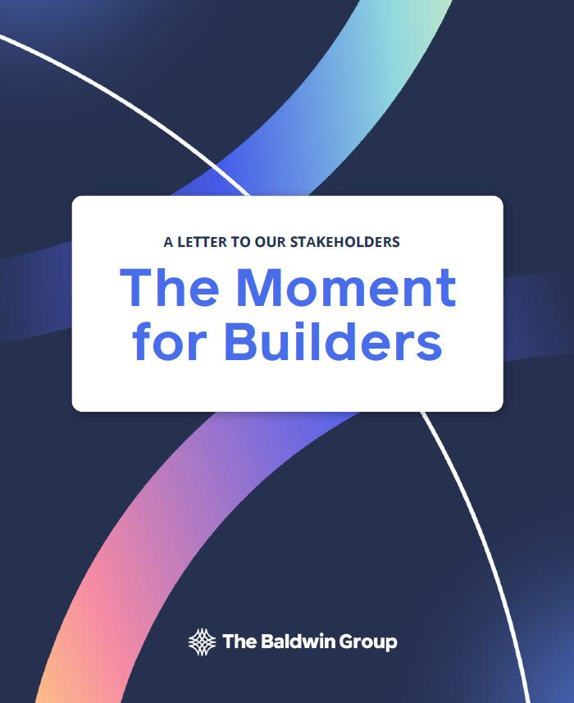

The Quiet Engine

Insurance is rarely described as a dream business. I have always believed that misses the true nature of the role this industry plays in our economy.

Nearly every first home in this country closes because insurance stands behind the mortgage. Nearly every new business takes its first swing because someone agreed to carry a risk the founder could not carry alone.

Factories are built, ships sail, cranes rise, capital moves, and new ideas are funded because insurance converts uncertainty into confidence. It is the quiet engine behind almost every act of ambition in our economy. It enables a family to take the risk of home ownership, an entrepreneur to take the risk of a first hire, an investor to take the risk of backing something unproven. It fuels economic growth, and it safeguards the value that growth creates.

At Baldwin, we call this Protecting the Possible. It is our True North, and it has been the work of this firm since the beginning.

I start there because this letter to our stakeholders is about a change in capital structure for The Baldwin Group, and it would be easy to read a change like that as a financial story. It is not. It is a story about what insurance makes possible, why we believe that work is about to profoundly improve for the people who depend on it, and why we are changing our capital structure to continue building the firm we believe will be at the forefront of that change.

The Right Partners for the Right Moment

The Baldwin Group is returning to private ownership, in partnership with DFO Management, the family investment office of Dell Technologies Founder, Chairman, and CEO Michael Dell, and Sequence Holdings. Our vision is unchanged. Our strategy is unchanged. Our leadership and our culture are unchanged. The only thing changing is the capital structure around the firm, and we are changing it because the moment in front of us demands it.

There is no perfect capital structure. There is only the right one for the moment, and disciplined judgement is required to recognize when the moment has changed. We exercised that judgement before and chose to move in the opposite direction. Understanding why requires a short review of how this firm was built.

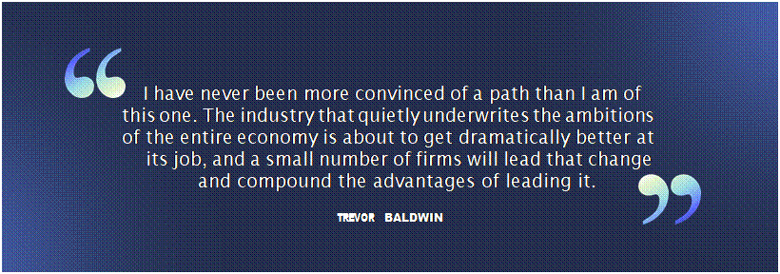

2 baldwin.com | 

What We Built, and How We Built It

The Baldwin Group was built by colleagues. Some are native to Baldwin; many others joined through partnerships (our nomenclature for mergers and acquisitions). Together they have been woven into one team, one culture. And from the start, we built differently than the industry around us.  A decade ago, the fashionable strategy in insurance distribution was simple: raise private equity capital, buy agencies as fast as possible, integrate them lightly or not at all, and create value through the arithmetic of merger arbitrage. Buy at one multiple, trade at a higher one, repeat. Plenty of firms ran that playbook capably. Merger arbitrage, in and of itself, however, does not produce an enduring value creation flywheel. This was never our playbook.  We chose another path. The Baldwin Group went public in 2019. We used the currency and transparency of the public markets to pursue something harder and, we believed, far more durable: assembling a diversified portfolio of capabilities and talent, not just books of business, into a fully integrated firm operating in a common environment. Our partnerships did not sit beside the firm. They became the firm. The thesis at its core was simple: build scale and expertise for the benefit of clients and colleagues. If we took care of our clients and colleagues, made decisions through the lens of what upholds their best interests as our True North, then the |  | fortunes of our business would follow. So far, that has proven to be abundantly true.  The record of our journey tells a compelling story. Six consecutive years of top-of-industry organic growth, at multiples of the peer median. A diversified platform serving individuals, families, and businesses of every size and complexity, alongside proprietary products, reinsurance broking, and risk capital capabilities that most distributors never build. Eleven consecutive years recognized as a Best Place to Work.  That instinct, to zig when others zag, is not contrarianism for its own sake. Each move was the right structure for its moment.  Going public worked. The public markets gave us privileged access to capital when we needed it most. They gave us a currency that allowed us to pursue a growth strategy unique in our industry. They imposed a discipline of transparency and execution rigor that made us better operators, and they enabled thousands of colleagues to become owners of the firm they were building. A meaningful part of what The Baldwin Group is today was built with tools only the public markets provide. Our decision to change our capital structure is not a write-off of public ownership. It is entirely possible, maybe even likely, that we are a public company again one day.



3 baldwin.com



The Window

This moment is defined by two forces arriving at once: the greatest increase in talent mobility our industry has seen in decades, and artificial intelligence capable of rewiring how the work of insurance is done. Either alone would represent a defining moment. Together they present a once-in-a-generation opportunity.  So, it is not surprising that the war for talent in our industry has escalated sharply over the past two years, and it will likely escalate further. Consolidation has shaken loose thousands of skilled professionals. Every firm is recruiting. Advisors, client experience professionals, and entire teams are moving at a pace this industry has not seen in decades. While some of these moves are purely about near term economics, many professionals are stepping back and taking stock of the shifting dynamics at play and assessing industry platforms for the talent, tools, and capabilities they offer to elevate client outcomes and career trajectory.  Our results are, and have always been, a talent story. With the ownership and partners now behind us, we intend to lean further into that advantage than we have been able to as a public company in the current environment: in recruiting, in development, in the tools we place in colleagues' hands, and in the ownership opportunities we extend to the people who build. We plan to be the destination for the most talented and ambitious professionals.  Part of building that destination is the infrastructure we have put in place since becoming a public company, creating the technology and capabilities that accelerate and expand the impact our professionals can have for clients. In addition, several years ago, we began a deliberate, firm-wide effort to understand what artificial intelligence could actually do for the work of insurance. Not a pilot in a corner of the firm. A sustained experiment across it, run by the people who do the work. We wanted to know, not guess. The answer is now clear to us, and it is bigger than we expected. |  | AI will change how work is done in our industry more than any technology in its history, and it will change it for the better. Not by replacing the judgment, the relationships, and the expertise that define great advisors and underwriters, but by removing nearly everything that gets in their way and providing new tools and insights that profoundly change the value they deliver to clients and partners. The hours our best people spend gathering, rekeying, reconciling, and chasing are hours they are not spending with clients, on strategy, on the work only they can do. We intend to give those hours back and then compound them.  We are not automating the way brokers and underwriters have historically worked. We are redesigning it, end to end: accelerating insights, compressing cycle times that clients have been patient with for far too long, and positioning every colleague to operate at the top of their game, delivering the maximum impact they are capable of. This work is under way inside Baldwin, and it is already producing results. What changes now is the pace.  This is not only about efficiency and faster cycle times. The same technology is producing predictive pricing that reflects risk in real time, claims analytics that prevent losses before they happen rather than just processing them after the fact, sharper appetite matching between risk and capacity, better insights for continued development of proprietary products, and claims servicing that resolves faster and more fairly for the people who count on it.

4 baldwin.com

 |  | Capitalizing on the Moment  Our advantages here are specific, not aspirational. We spent a decade integrating when integration was unfashionable, our data is structured, connected, and accessible in a way that most of our industry, fragmented across thousands of lightly stitched-together agencies, simply cannot match. We operate one platform, not a federation of them. And we have momentum, which in this particular race matters more than size. Our firm is in a unique position to couple the existing infrastructure built since our IPO with accelerated AI investments to drive profitable growth. DFO Management and Sequence make that advantage tangible: DFO’s long-duration, founder-aligned capital funds the investment at the pace this moment requires, while Sequence’s dedicated technology team stands ready to help us execute on it. Together, we will widen the lead we have already built.  There is a growing conversation in our industry about whether this moment belongs to a disruptive challenger — a firm with technology at its center, long term capital behind it, and the will to build differently. We think that diagnosis is exactly right. Where we differ is the assumption that such a challenger must start from a blank sheet of paper. A blank sheet has no talent, no clients, no data, no carrier relationships, and no trust. We intend to be that challenger — with a fifteen-year head start.  Most importantly, everything this technology accelerates for us; it accelerates for the people insurance serves. Faster answers for a family closing on a home. Broader availability of coverage in markets where capacity has been scarce. Sharper pricing, built on better insight. New products for risks that did not exist five years ago. When insurance gets faster, smarter, and more available, more homes are bought, more businesses are started, more risks are taken, and more dreams are underwritten. The social value our industry quietly provides continues to grow.  My conviction, and the urgency behind this decision, is that over the next several years a handful of winners, perhaps fewer, will emerge with advantages that compound recursively: better tools attract better talent, better talent wins more clients, more clients produce more data and more resources to invest, and the flywheel turns faster with every rotation. Advantages built that way widen the chasm between the very best firms and the rest of the pack. We intend to be one of those winners, and we believe we have a compelling start.  That ambition requires investment at a pace, a scale, and a confidence that the public markets do not currently tolerate, and it requires the freedom to move on strategic opportunities, including M&A, at the speed the moment demands rather than the speed the quarterly cycle allows. In an industry where scale and pace of investment increasingly determine competitive position, that speed is itself a strategic advantage. Listed peers will be pressed to harvest the gains from AI as near-term margin.  Private ownership lets us compound them instead — into client value, into growth, into the flywheel. It gives us the freedom to go on offense.

5 baldwin.com



The Decision

A disciplined assessment of this moment points toward a needed shift. Public markets reward what they can measure quarterly. The opportunity in front of us will be built over years and it requires a level of investment and a tolerance for the spend and leverage that ambitious building involves, that public markets are not rewarding today. We have watched enormous amounts of sector value move on macro sentiment disconnected from how the underlying businesses actually perform. None of that changes who we are, but it does change what our business can do while listed.

There is a second reason, and it concerns our colleagues. Thousands of the people who built this firm own it. Ownership is one of the most powerful tools we have for attracting and retaining the industry’s best builders, and it’s most powerful when the value of what they hold reflects the progress they are making. In the current market, it does not. When the arbiter of value does not recognize the investments being made in pursuit of an opportunity of this size, that becomes a distraction for the very people we most need focused on the work. Partners who share our conviction, and whose time horizon matches the opportunity, are the better home for that ownership.

When the structure stops serving the strategy, it’s our job to change the structure, not the strategy.

What Changes, and What Doesn't

What changes at The Baldwin Group is narrow: the quarterly rhythm, and the constraints it places on long-term investment and strategic flexibility. What does not change is more important.

Our vision is the same one we have been executing for years: building the most diversified, vertically integrated insurance firm of the future, participating at every level of the value chain, and building the leading platform in the industry for the most talented and ambitious professionals.

Colleague ownership continues. The Baldwin Group’s identity was built in part on being the largest significantly colleague-owned publicly traded insurance broker. It is how this firm works: the people who build the value own a meaningful piece of it. That principle carries into this next chapter intact. Ownership is how we have always aligned the firm, and it is how we will continue to reward the builders in this next chapter.

Our chosen capital partners reflect the position of strength from which this decision is made. DFO Management and Sequence are well established, deeply resourced, and share our long-term vision. They are backing the plan actively, not simply funding it.

6 baldwin.com

A Home for Builders

The journey we are on, the path we have taken, is not for everyone. Innovation, rewriting and reimagining industry norms, fighting against the status quo is difficult and at times unforgiving work. It requires a willingness to make hard decisions, take calculated risks, and an abundance of grit to fortify against inevitable failures that plant the seeds of our future innovation and success.

We expect a lot of each other. We work hard. Perfection is the goal, with excellence as the expectation, and we say that without apology. We give honest feedback, we hold high standards, and we ask every colleague to take accountability, move first, and fix what is broken rather than explain why it broke. Some very talented people prefer a different bargain.

But if you are a builder, there is no better home in this industry. We have built entrepreneurship into the architecture of the firm, in every function, at every level. Advisors who want to build a book with the backing of a platform most professionals only touch at the largest institutions. Operators who find a better way and want to own the result. Technologists who want their work in front of clients in weeks, not years. Underwriters who want to build product, not just place it. At Baldwin, the builders get the platform, the runway, and the recognition to do the work of their careers and have a hand in building the most advanced tools in the industry, fueled by an ownership structure built for speed.

Every colleague a builder. Every function a place where building is rewarded. The firm we are becoming does not happen by inertia. It happens because thousands of people decide to build it.

What This Means for You

To our colleagues: The Baldwin Group’s future is bright. Your opportunity to share in the growth of our firm continues. Your earnings opportunity grows as the firm grows, and we intend to grow considerably. And the most meaningful work of your career, work that reaches more clients, moves faster, and matters more, will be more available at Baldwin than anywhere else in this industry. You are not watching this chapter; you are writing it.

To our clients: everything we have built and are building exists to serve you. This change accelerates our ability to deliver innovative solutions and profoundly positive impact for you. Better advice delivered faster. Sharper solutions to more complex problems. Advisors with more resources and expertise to do the work that protects what you are building. You will feel this change in outcomes, not announcements.

To the builders across our industry: if you want to maximize your earnings, your client impact, and your growth as a professional, working alongside the best and brightest with the most advanced tools in the industry supporting you, we would like to meet you. The best time to join a build is at the beginning. This is the beginning of our next chapter — what I expect will be the most consequential yet.

To the founders and leaders of firms thinking about their future: many of you will field calls from buyers whose model is built on aggregation and arbitrage. If that is the outcome you want, there are plenty of homes for you. If you want your firm to remain on the vanguard, your clients to have access to capabilities you could not build alone, your people to have real careers rather than a soft landing, and your rollover equity to participate directly in the value this next chapter creates, Baldwin is the best home in the industry, and we will prove it in diligence, not adjectives.

To our insurance company partners: our trajectory is your opportunity. We are built to deliver what you value most, sustained growth and high-quality premium. The investments described here make us a faster, smarter, more consistent distribution and underwriting partner. We intend to grow together.

7 baldwin.com

What's Next

I have never been more convinced of a path than I am of this one. The industry that quietly underwrites the ambitions of the entire economy is about to get dramatically better at its job, and a small number of firms will lead that change and compound the advantages of leading it. We have spent fifteen years assembling exactly the platform, the data, the capabilities, and above all the people that this moment requires. Now we have the ownership, and the partners, to match.

Every day our clients are pursuing what is possible, for themselves, their families and their businesses, in a world where risk grows more complex and more connected each year. Our job is to build faster than the risks change. The freedom and the pace this next chapter unlocks will enable us to continue protecting the possibilities our clients are chasing.

If you are a builder, a dreamer, an entrepreneur, come build what’s possible and own what’s next with us.

Trevor Baldwin
Chief Executive Officer
The Baldwin Group



8 baldwin.com

Cautionary Statement Regarding Forward-Looking Statements

Some of the statements contained in this communication and other written and oral statements made from time to time by us and our representatives are forward-looking statements and not statements of historical or current fact. We have based these forward-looking statements on our current expectations, and these statements are subject to known and unknown risks, uncertainties and assumptions. Forward-looking statements include, but are not limited to, statements relating to: our goals, plans, and strategic initiatives; long -term growth prospects; maximizing value for our stockholders; and other events, conditions or developments that will or may occur in the future; and timing of any of the foregoing. You can identify forward-looking statements by terminology such as “may,” “will,” “should,” “could,” “expects,” “intends,” “plans,” “anticipates,” “believes,” “estimates,” “predicts,” “projects,” “forecast,” “outlook,” “assume,” “potential” or “continue” or variations or the negative counterparts of these terms or other comparable terminology. These statements are only predictions and are no guarantee of future performance, and investors should not place undue reliance on forward-looking statements as predictive of future results. Actual events or results may differ materially from those stated or implied by these forward-looking statements. In evaluating these statements and our prospects, you should carefully consider the factors set forth below. All forward-looking statements attributable to us or persons acting on our behalf are expressly qualified in their entirety by these cautionary factors and to others contained throughout this communication.

Forward-looking statements by their nature address matters that are, to different degrees, uncertain, such as statements regarding the transactions contemplated by the Agreement and Plan of Merger, by and among the Company, The Baldwin Insurance Group Holdings, LLC, Square Acquisition Parent, Inc. (“Buyer”), Square Acquisition Merger Sub I, Inc. and Square Acquisition Merger Sub II, LLC (the “Transaction”). All such forward-looking statements are based upon current plans, estimates, expectations, opportunities and ambitions that are subject to risks, uncertainties, assumptions, and other important factors, many of which are beyond the control of the Company, that could cause actual results to differ materially from those expressed in such forward- looking statements. Key factors that could cause actual results to differ materially include, but are not limited to, the expected timing and likelihood of completion of the Transaction, including the timing, receipt and terms and conditions of any required governmental and regulatory approvals; the occurrence of any event, change or other circumstances that could give rise to the termination of the Transaction; the possibility that the Company’s stockholders may not approve the Transaction; the risk that the parties may not be able to satisfy the conditions to the Transaction in a timely manner or at all; risks related to disruption of management time from ongoing business operations due to the Transaction; the risk that any announcements relating to the Transaction could have adverse effects on the market price of the Company’s common stock; the risk that the Transaction and its announcement could have an adverse effect on the parties’ business relationships and business generally, including the ability of the Company to retain customers and retain and hire key personnel and maintain relationships with their suppliers and customers, and on their operating results and businesses generally; the risk of unforeseen or unknown liabilities; customer, stockholder, regulatory and other stakeholder approvals and support; the risk of unexpected future capital expenditures; the risk of potential litigation relating to the Transaction that could be instituted against the Company or its directors and/or officers; the risk associated with third-party contracts containing material consent, anti-assignment, transfer or other provisions that may be related to the Transaction which are not waived or otherwise satisfactorily resolved; significant costs, or expenses incurred in connection with the Transaction; Buyer’s ability to obtain the necessary financing arrangements set forth in the commitment letters received in connection with the Transaction; certain restrictions contained in the Agreement and Plan of Merger that may impact the Company’s ability to pursue certain business opportunities or strategic transactions; the risk of various events that could disrupt operations, including pandemics, epidemics or other public health crises or severe weather (such as droughts, floods, avalanches and earthquakes), cybersecurity attacks, security threats and governmental response to them, and technological changes; the risks of labor disputes, changes in labor costs and labor difficulties; and the risks resulting from other effects of industry, market, economic, legal or legislative, political or regulatory conditions outside of the Company’s control. All such factors are difficult to predict and are beyond our control, including those detailed in the Company’s annual report on Form 10-K for the fiscal year ended December 31, 2025, which was filed with the U.S. Securities and Exchange Commission (the “SEC”) on February 26, 2026 (the “Form 10-K”), quarterly reports on Form 10-Q and other documents subsequently filed by the Company with the SEC. The Company’s forward- looking statements are based on assumptions that the Company believes to be reasonable but that may not prove to be accurate. Other unpredictable factors not discussed in this communication could also have material adverse effects on forward-looking statements. The Company does not assume an obligation to update any forward-looking statements, except as required by applicable law. These forward-looking statements speak only as of the date hereof.

9 baldwin.com

Additional Information and Where to Find It

In connection with the Transaction, the Company will file with the SEC a proxy statement on Schedule 14A. The definitive proxy statement will be sent to the stockholders of the Company seeking their approval of the Transaction and other related matters. In addition, certain participants in the Transaction will file a Transaction Statement on Schedule 13E-3 (the “Schedule 13E-3”) with the SEC. The Company and the other participants in the Transaction may also file other relevant documents with the SEC regarding the Transaction. This communication is not a substitute for the proxy statement on Schedule 14A (if and when available), the Schedule 13E-3 (if and when available) or any other document that the Company or the other participants in the Transaction may file with the SEC with respect to the Transaction.

BEFORE MAKING ANY INVESTMENT OR VOTING DECISION, INVESTORS AND SECURITY HOLDERS OF THE COMPANY ARE URGED TO READ THE PROXY STATEMENT ON SCHEDULE 14A (INCLUDING ANY AMENDMENTS OR SUPPLEMENTS THERETO OR INCORPORATED BY REFERENCE THEREIN) WHEN IT BECOMES AVAILABLE, THE SCHEDULE 13E-3 (INCLUDING ANY AMENDMENTS OR SUPPLEMENTS THERETO OR INCORPORATED BY REFERENCE THEREIN), AS WELL AS ANY OTHER RELEVANT DOCUMENTS FILED OR THAT WILL BE FILED WITH THE SEC IN CONNECTION WITH THE TRANSACTION, BECAUSE THEY WILL CONTAIN IMPORTANT INFORMATION REGARDING THE COMPANY, THE TRANSACTION AND RELATED MATTERS.

Investors and security holders may obtain free copies of these documents, including the proxy statement, and other documents filed with the SEC by the Company through the website maintained by the SEC at https://www.sec.gov. Copies of documents filed with the SEC by the Company will be made available free of charge by accessing the Company’s website at https://ir.baldwin.com/financials/sec-filings or by contacting the Company via email by sending a message to IR@baldwin.com.

Participants in the Solicitation

The Company, Buyer and their respective directors and executive officers may be deemed to be participants in the solicitation of proxies from the stockholders of the Company in connection with the Transaction under the rules of the SEC. Information about the directors and executive officers of the Company and other persons who may be deemed to be participants in the solicitation of stockholders of the Company in connection with the Transaction and a description of their direct and indirect interests, by security holdings or otherwise, will be included in the proxy statement and other relevant material related to the Transaction, which will be filed with the SEC when they become available, and may be found in the Company’s definitive proxy statement in connection with its 2026 Annual Meeting of Stockholders, as filed with the SEC on April 22, 2026 (the “2026 Proxy Statement”), and in the Form 10-K. Information about the directors and executive officers of the Company, their ownership of the Company common stock, and the Company’s transactions with related persons is set forth in the sections entitled “Directors, Executive Officers and Corporate Governance,” “Executive Compensation,” “Security Ownership of Certain Beneficial Owners and Management and Related Stockholder Matters,” and “Certain Relationships and Related Transactions, and Director Independence” included in the Form 10-K, and in the sections entitled “Corporate Governance,” “Compensation Discussion and Analysis,” “Compensation Tables,” and “Security Ownership of Certain Beneficial Owners and Management,” included in the 2026 Proxy Statement. Additional information regarding the interests of such participants in the solicitation of proxies in respect of the Transaction will be included in the proxy statement and other relevant materials to be filed with the SEC when they become available. These documents can be obtained free of charge from the SEC’s website at www.sec.gov.

No Offer or Solicitation

This communication is not intended to and shall not constitute an offer to sell or the solicitation of an offer to sell or the solicitation of an offer to buy any securities or the solicitation of any vote or approval, nor shall there be any sale of securities in any jurisdiction in which such offer, solicitation or sale would be unlawful prior to registration or qualification under the securities laws of any such jurisdiction. No offer of securities shall be made except by means of a prospectus meeting the requirements of Section 10 of the Securities Act of 1933, as amended.

10 baldwin.com

